**COGNIZANT**

**Week- Hands on**

**Assignments**

**Spring REST**

**Name: *Pranesh E S***

**Super Set ID: *6393970***

**Spring REST**

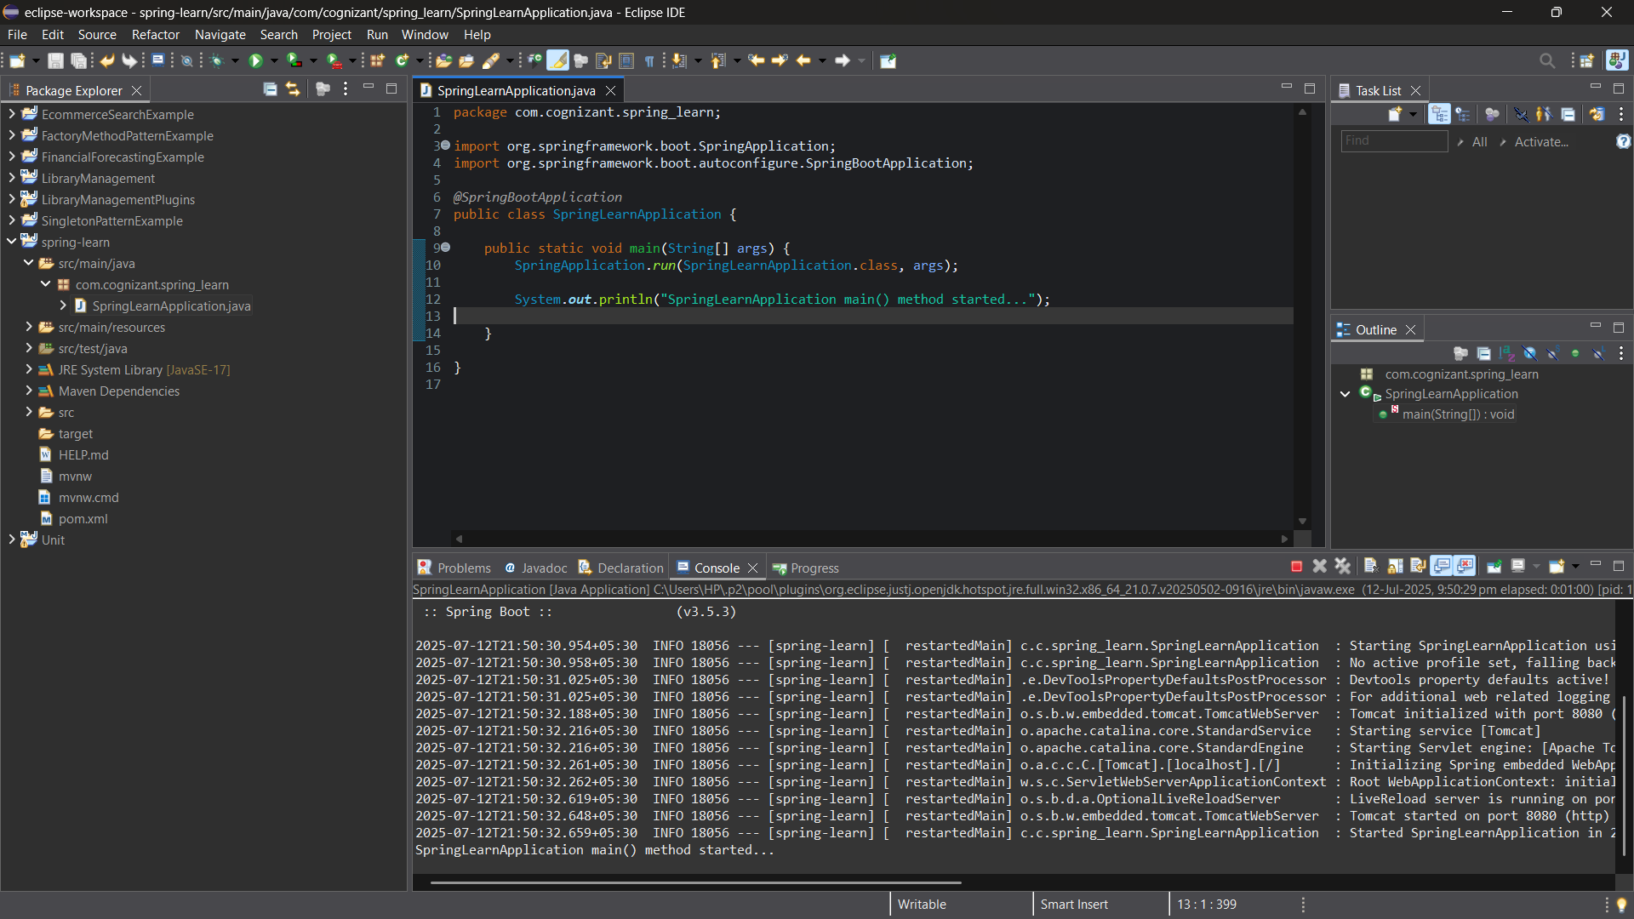**Question-1(Create a Spring Web project using Maven)**

**Question-2(Load Country from Xml)**

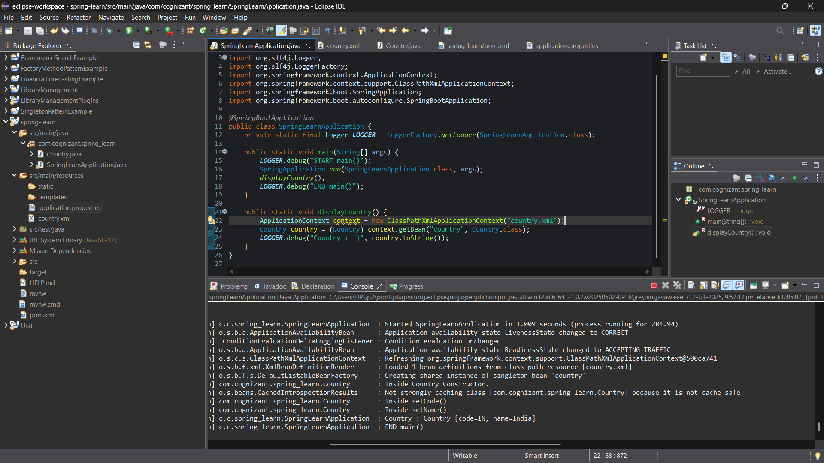

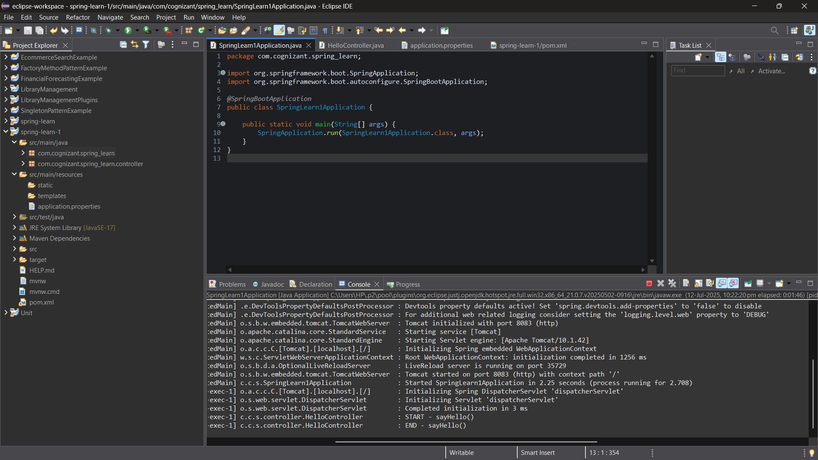**Question-3(Hello World Restful Web service)**

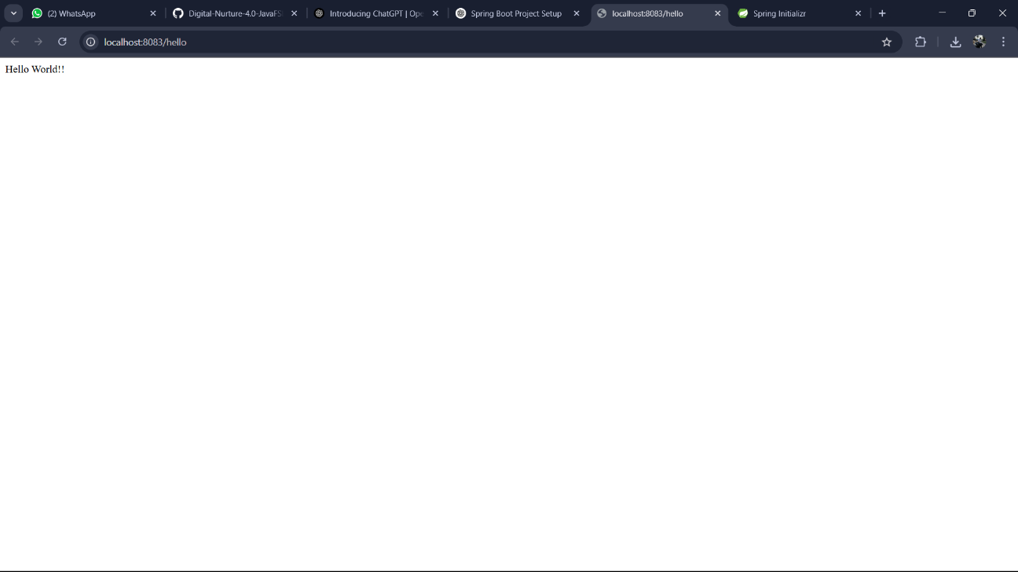

**Question-4(Rest-Country Web Service)**



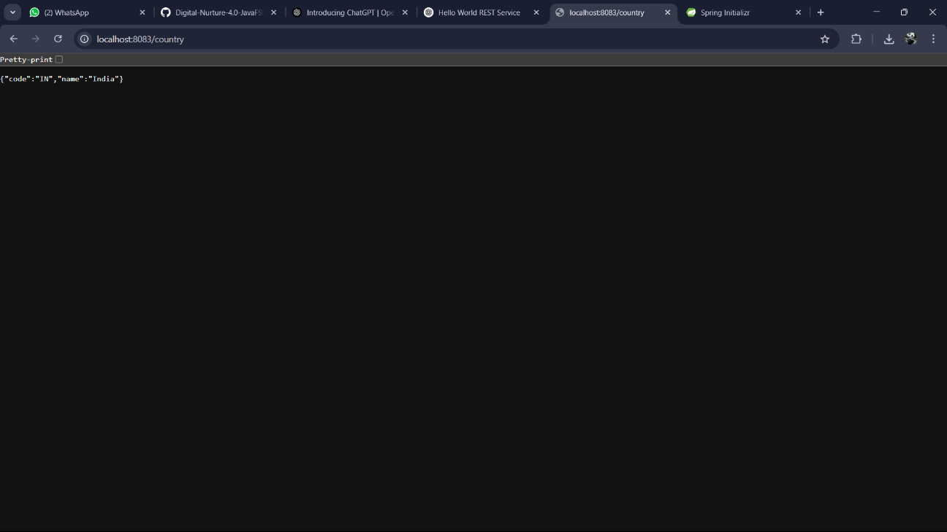

**Question-5(Rest-Get country based on country code)**

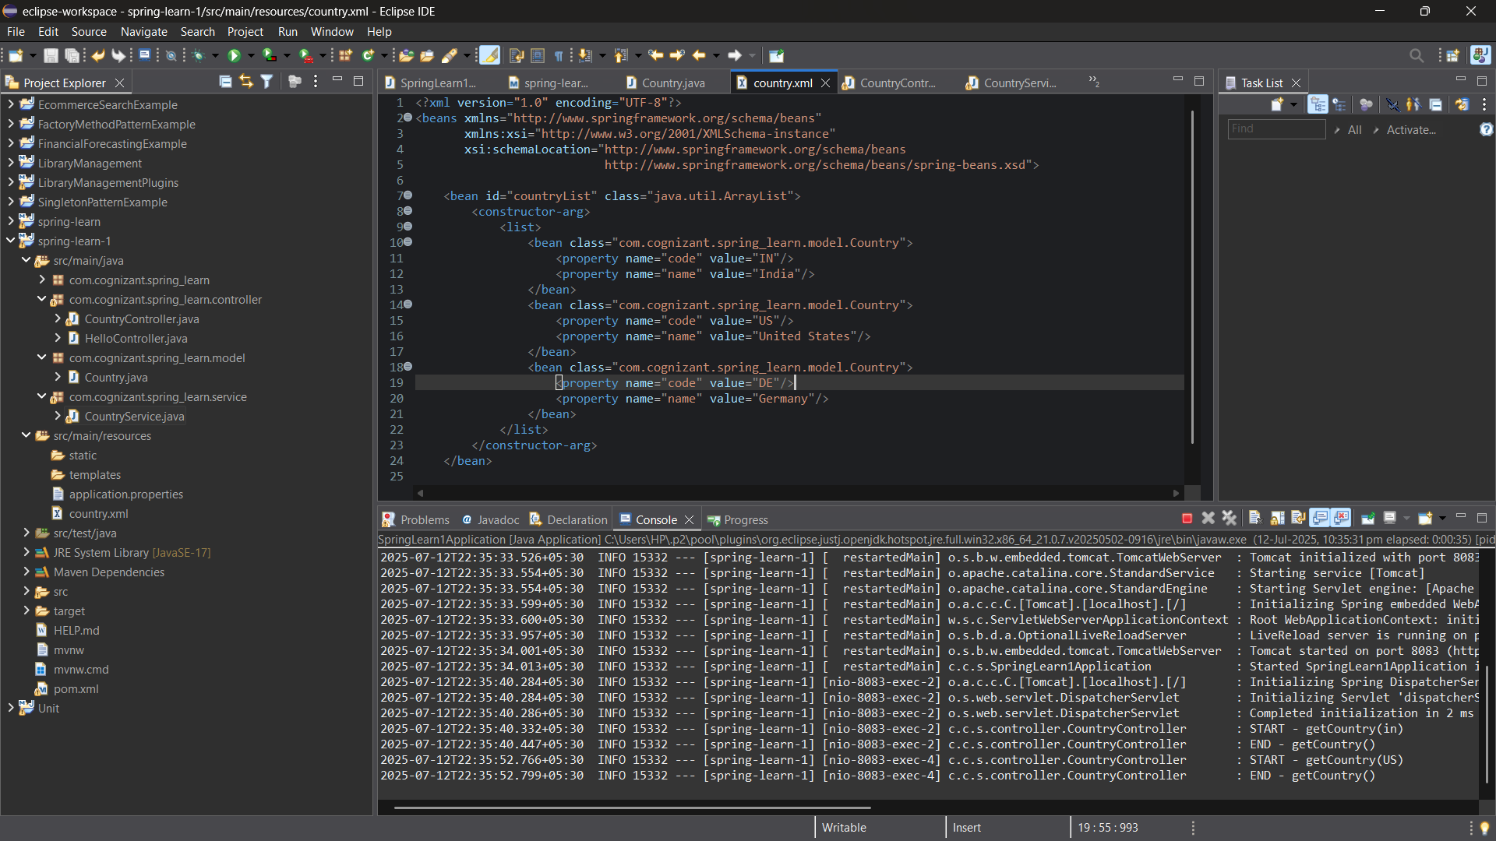

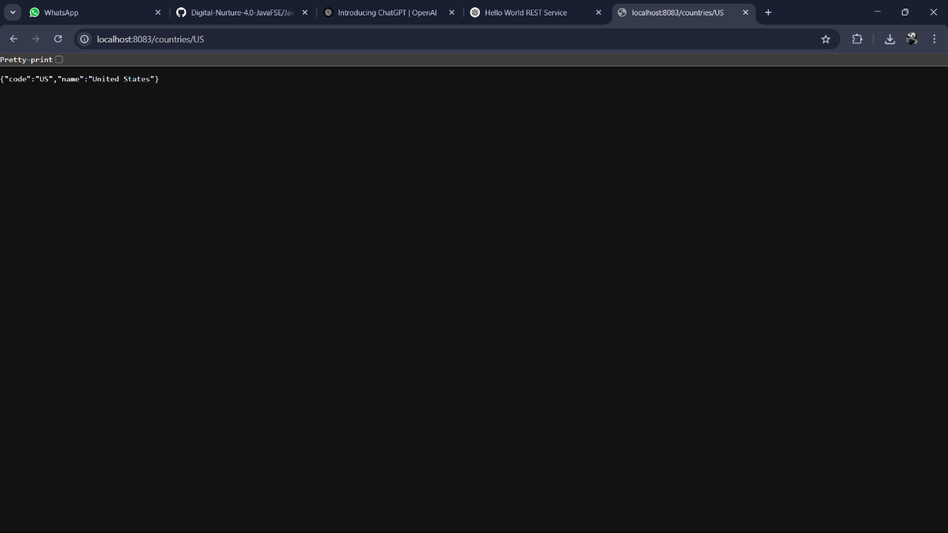

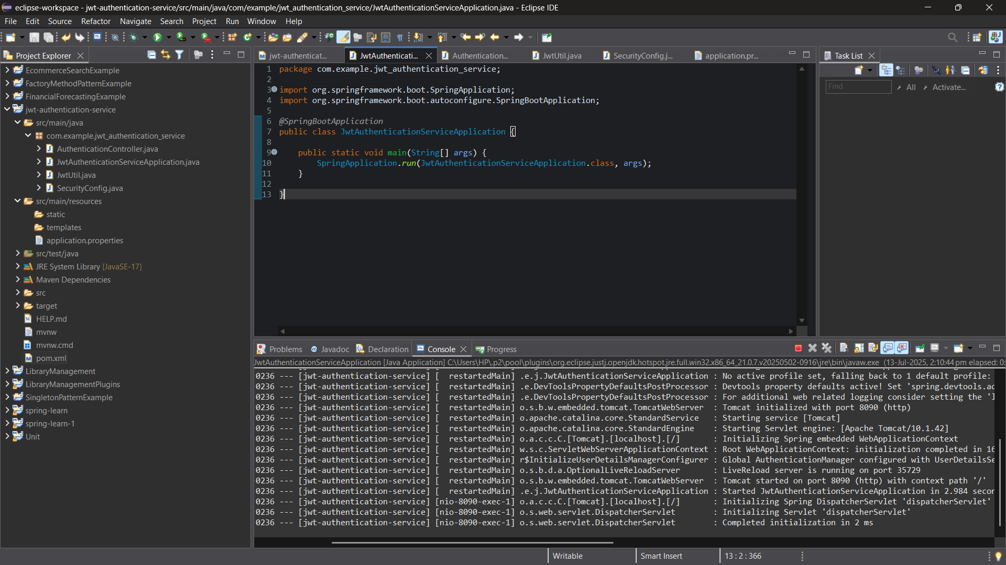**Question-6(Create authentication service that returns JWT)**

